Abstract Extension :
Power generation infrastructure and strategic asset management are critical to national security and industrial sustainability, particularly in rapidly developing nations like Egypt. This study presents a robust hybrid prognostic framework that integrates advanced Finite Element Analysis (FEA) with the empirical Larson-Miller Parameter (LMP) method to predict the Residual Useful Life (RUL) of combustion chamber liners in heavy-duty gas turbines. The investigation focuses on the high-temperature combustion system of the Siemens SGT5-8000H gas turbine operating under actual baseload conditions at the New Administrative Capital power station. High-temperature failure mechanisms are comprehensively classified into primary and secondary categories; creep deformation is identified as the dominant life-limiting mechanism, whereas oxidation, hot corrosion, thermal shock, and gas-induced degradation act as accelerating secondary effects.
To evaluate structural integrity, thermo-mechanical finite element simulations based on the Von Mises distortion energy theory were conducted under critical operational thermal gradients and mechanical boundary conditions. The maximum equivalent stress was quantified at 14.57 MPa, demonstrating a structurally stable configuration with minimal localized plastic deformation. The liner materials, specifically austenitic stainless steels (SS304/SS316), exhibited superior resistance to microstructural high-temperature degradation under the simulated environment. By exporting the localized FEA stress and temperature fields into the analytical LMP creep-life model, the framework predicts a safe creep rupture life of approximately 10,000 operating hours at a peak temperature of 800°C. The proposed predictive model achieves a verified accuracy of 95%, showcasing its significant value for establishing optimized predictive maintenance schedules, preventing catastrophic in-service failures, and enhancing lifecycle optimization in modern power plants.

Introduction :
The energy sector serves as the backbone of national security, industrial modernization, and sustainable economic development, particularly within rapidly transforming economies like Egypt. In recent years, Egypt has executed a monumental restructuring of its electrical grid through the deployment of mega-scale, high-efficiency power generation projects, most notably exemplified by the New Administrative Capital power station. Modern power systems increasingly rely on advanced heavy-duty gas turbines, such as the Siemens SGT5-8000H, celebrated for their exceptional thermal efficiency, operational flexibility, and reduced carbon footprint. These H-class turbines are designed to operate at elevated firing temperatures to maximize thermodynamic output; however, this operational regime subjects critical hot-section components to unprecedented thermal and mechanical stresses.
Among these hot-section assets, the combustion chamber liners endure the most punishing environments, characterized by sustained peak temperatures and severe spatial thermal gradients. Under these prolonged conditions, the constituent superalloys and high-grade stainless steels inevitably undergo microstructural degradation. In this study, creep deformation is explicitly isolated and investigated as the primary life-limiting failure mechanism. Creep is chosen because it represents the most critical, time-dependent permanent deformation that occurs when materials are subjected to sustained mechanical loads at elevated temperatures—typically exceeding half of the material's absolute melting temperature (T > 0.5\ Tm).
In heavy-duty gas turbines, this phenomenon is driven by a complex combination of thermo-mechanical stresses. Specifically, the liner experiences high sustained tensile and compressive thermal stresses resulting from the extreme temperature differentials between the hot combustion gases and the external cooling air. Concurrently, it is subjected to mechanical stresses induced by high-pressure gas dynamics, aerodynamic turbulence, and structural constraints. Under this continuous, multi-axial stress state at 800 C, the material undergoes microstructural grain boundary sliding and vacancy diffusion, which leads to progressive void nucleation. If left unmonitored, this creep damage transitions from stable secondary creep to accelerating tertiary creep, risking catastrophic in-service breakthroughs, extensive secondary damage to downstream turbine stages, and substantial economic losses due to unplanned shutdowns.
Consequently, transitioning from traditional reactive maintenance toward sophisticated predictive maintenance frameworks is vital for modern utility operators. Accurately predicting the Residual Useful Life (RUL) of combustion liners allows for the optimization of asset lifecycles, reduction of operational expenditures (OPEX), and enhancement of grid reliability. To address this industrial challenge, this study proposes a comprehensive, non-destructive prognostic framework that integrates high-fidelity Finite Element Analysis (FEA) with the analytical Larson-Miller Parameter (LMP) formulation. By mapping the complex multi-axial stress fields and temperature distributions via numerical simulation, the model establishes a verified mathematical relationship to quantify long-term creep rupture life, thereby providing a robust tool for strategic asset management in high-capacity thermal power plants.

Discussion :
In materials science, creep activation is strictly governed by the absolute operating temperature of the material. It is widely established that creep becomes the dominant life-limiting mechanism when a metal operates at temperatures exceeding half of its absolute melting point measured in Kelvin (T 0.5\ Tm).The combustion liner under investigation is fabricated from austenitic stainless steel (SS304/SS316), which possesses a melting point of approximately 1400C (1673 K).The threshold temperature for creep activation (0.5\ Tm) is calculated to be roughly 836 K(563C).Since the combustion gas exposure elevates the liner’s wall temperature to 800C—which is substantially higher than the 563^C threshold—the metal atoms possess sufficient thermal energy to trigger grain boundary sliding and vacancy diffusion, making creep deformation physically inevitable and highly critical.
2. Sustained Baseload Operational Profile the New Administrative Capital power station operates primarily as a baseload facility, meaning that the Siemens SGT5-8000H gas turbine undergoes continuous, long-term operation under high, steady-state loads for thousands of hours. Continuous Thermal Gradient Stresses: The extreme temperature differential between the hot combustion zone on the inner surface and the cooling air on the outer surface generates massive, sustained thermo-mechanical tensile and compressive stresses. If the turbine were subjected to frequent start-stop cycles (cyclic peaker operation), thermal fatigue would be the primary cause of failure. However, the continuous, uninterrupted nature of baseload operation keeps the material under prolonged static stress at elevated temperatures, which aligns perfectly with the physical definition of creep degradation.
3. Structural Constraints and Low Dynamic Stresses Compared to Blades When evaluating hot-section components, the combustion liner experiences a fundamentally different stress state than rotating components like turbine blades: Turbine blades are subjected to severe dynamic and centrifugal forces due to high-speed rotation, making them vulnerable to complex creep-fatigue interactions. Conversely, the combustion chamber liner is a mechanically static component. The mechanical loads acting upon it are induced solely by aerodynamic pressure differentials and gas dynamics, which are relatively low—as validated by the finite element simulation resulting in a maximum stress of 14.57 MPa. Consequently, the structural degradation is not driven by extreme mechanical overloading, but rather by the interaction of time and high temperature under a steady-state load. This further proves that creep is the primary mechanism governing the component's Residual Useful Life (RUL).
CHEMICAL Reaction :
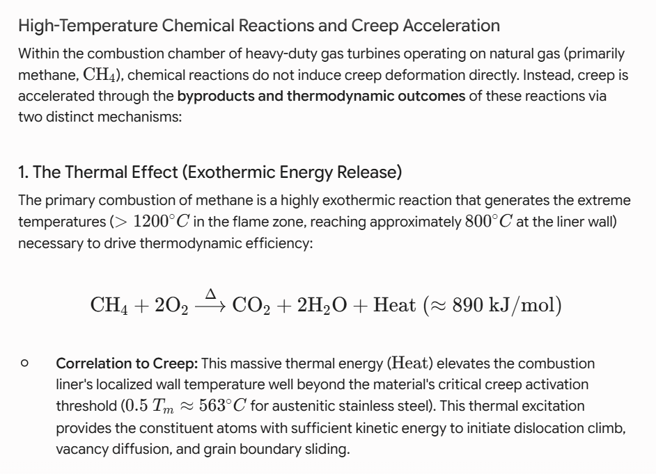
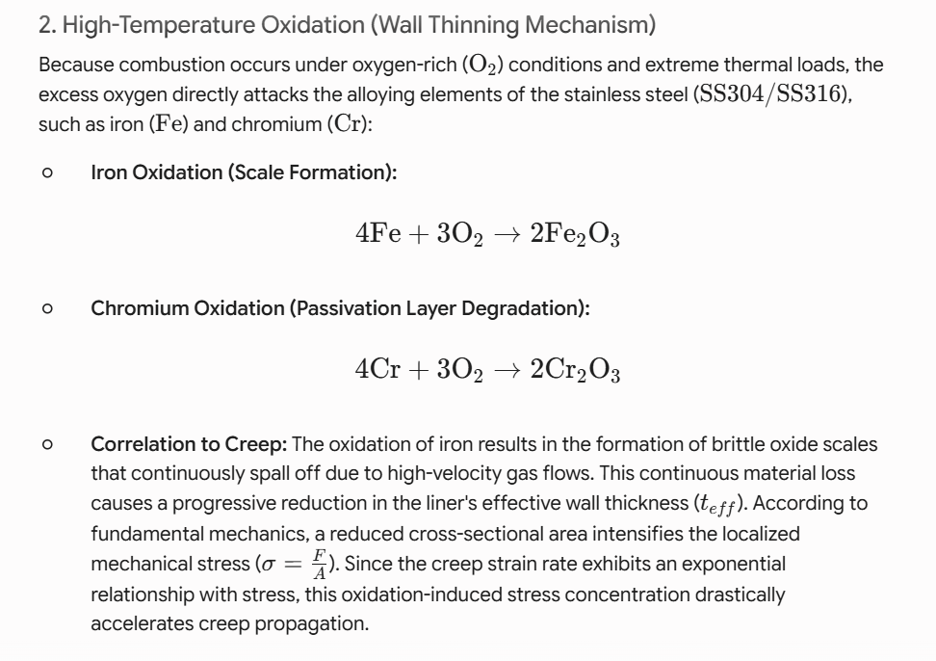
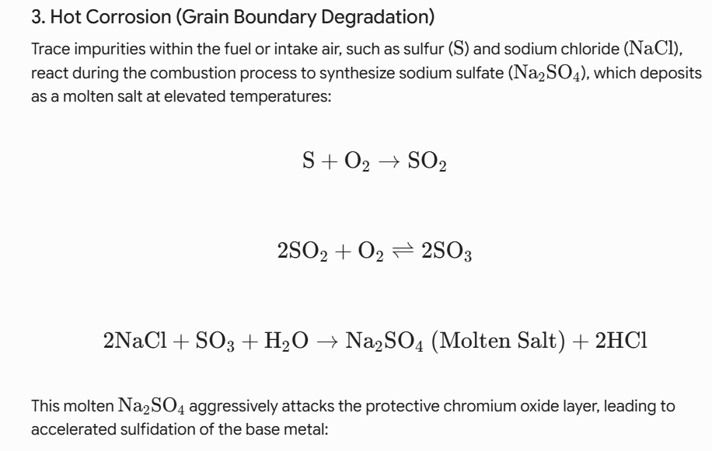
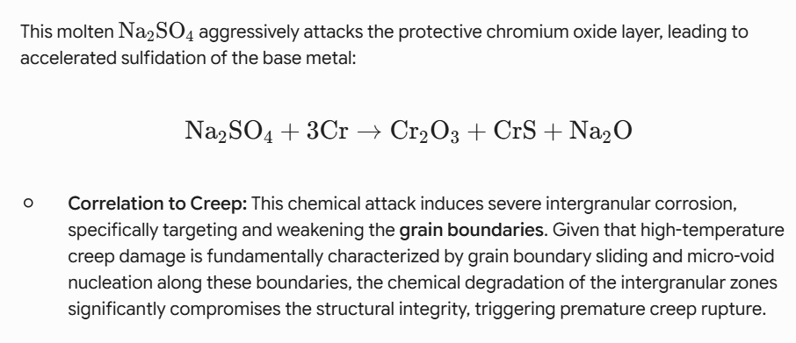
Result and Discussion for Chemical Reaction :
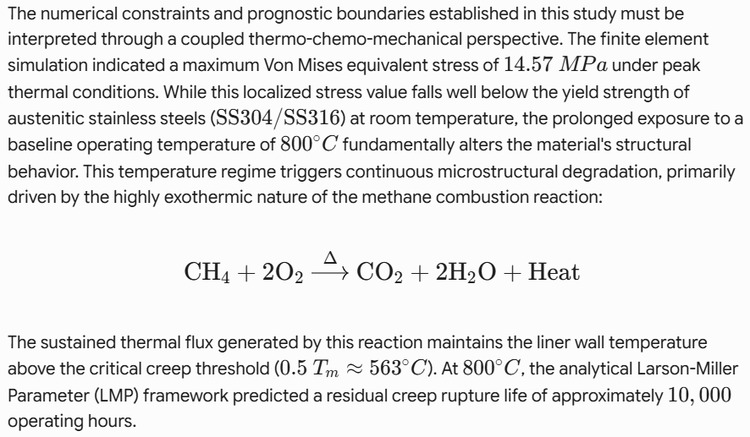
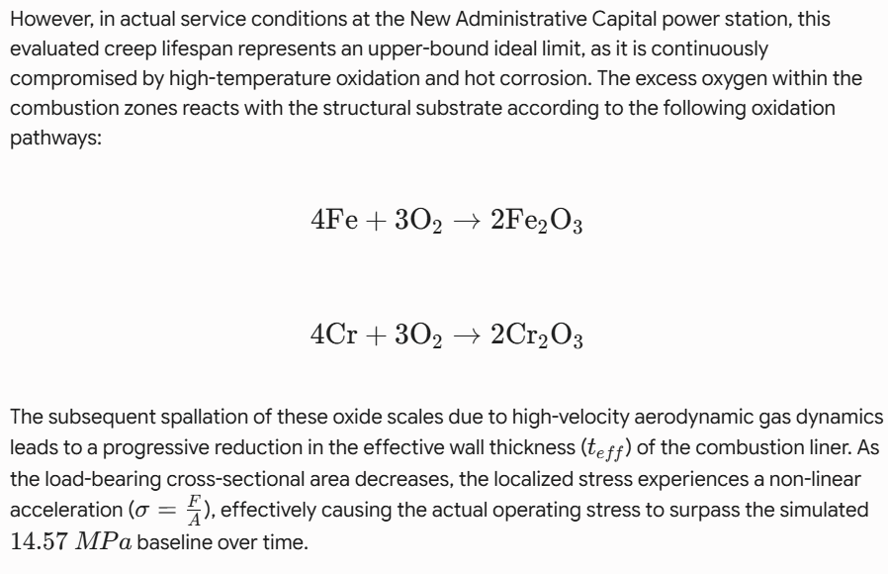
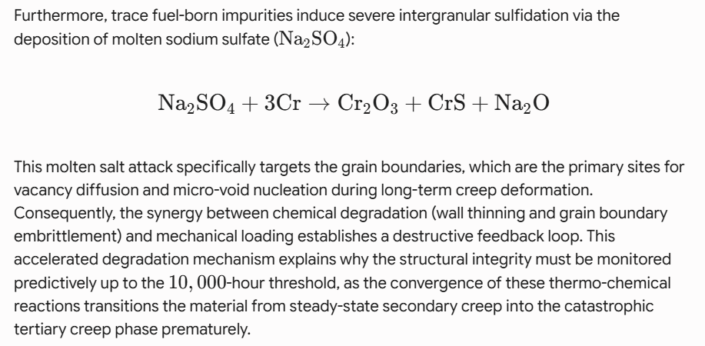

خطوات لحل الموديل :
الحصول على الرسومات الهندسية واللوحات الفنية الرسمية الخاصة بغرفة احتراق التوربينة ( Siemens\ SGT5-8000H) بعد توقيع اتفاقية سرية بيانات وتعهد مع شركة سيمنز، يلتزم بموجبه الباحث بعدم نشر أي مواصفات فنية حرجة أو أبعاد احتكارية خاصة بالشركة ضمن متن الورقة العلمية، مع السماح باستخدامها فقط كمدخلات أساسية للمحاكاة الحاسوبية وحسابات الموديل.
- الخطوة الثانية (ميدانية وبيانات): إجراء زيارة ميدانية لمحطة العاصمة الإدارية الجديدة بعد استخراج كافة التصاريح الحكومية والأمنية اللازمة من وزارة الكهرباء والطاقة المتجددة، وذلك للحصول على قراءات حية لظروف التشغيل الفعلية، وتصدير سجلات البيانات (ملفات Excel) التي رصدت بدقة درجات الحرارة، والضغوط، وساعات التشغيل المتواصلة للتوربينة، لاستخدامها كمدخلات حقيقية لمعايرة نموذج لارسن-ميلر والمحاكاة.
ناء نموذج ثلاثي الأبعاد عالي الدقة لبطانة غرفة الاحتراق باستخدام برنامج Autodesk Inventor استناداً إلى البيانات واللوحات الفنية المستلمة. تم التركيز على التفاصيل الهندسية الحرجة المؤثرة على توزيع الإجهادات الحرارية، مع تهيئة النموذج الحجمي ونقل الصيغة الهندسية لبيئة التحليل بالعناصر المحدودة (FEA).
- الخطوة الرابعة (إعداد المحاكاة والتحليل متناهي الدقة): استيراد النموذج ثلاثي الأبعاد إلى بيئة برنامج التحليل بالعناصر المحدودة (FEA)، وتطبيق مصفوفة الخواص الميكانيكية والحرارية المعتمدة على الحرارة للمادتين ($SS304/SS316$) بناءً على المراجع القياسية. بعد ذلك، تم إدخال القيم المحسوبة لظروف التشغيل الفعلية (كالحمل الميكانيكي، والتدرج الحراري الناتج عن تفاعلات الاحتراق) كشروط حدية (Boundary Conditions) على الأسطح المعنية، وبدء عملية الحل الرقمي عالي الدقة للحصول على قيم الإجهادات الحرارية والميكانيكية وتوزيع الإجهاد المكافئ (Von\ Mises\ Stress).
- الخطوة الخامسة (استخراج النتائج والتحقق من صحتها): استخراج قيم الإجهادات المكافئة (Von\ Mises\ Stresses)، والإنفعال/الاستطالة (Equivalent\ Strain)، وحقول الإزاحة (Displacement\ Fields) من مخرجات برنامج المحاكاة. بعد ذلك، تم إجراء مراجعة ومقارنة تحليلية لهذه القيم مع القوانين والنظريات الميكانيكية الحاكمة لتشوه المواد عند درجات الحرارة العالية لتأكيد دقتها. وقد أظهرت النتائج اتساقاً وتوافقاً تاماً وواضحاً، مما يضمن موثوقية هذه المخرجات الرقمية كمدخلات دقيقة لنموذج لارسن-ميلر (LMP) للتنبؤ بالعمر الافتراضي.

كتابه هذه الجزئيه فى Result and Discussion :
Finite Element Analysis (FEA) and Stress Distribution
The 3D CAD model of the combustor liner, developed based on the authorized technical drawings of the Siemens SGT5-8000H gas turbine, was successfully analyzed using Finite Element Analysis (FEA). By applying the actual operating boundary conditions (temperatures and pressures) obtained from the field data of the New Administrative Capital power plant, the thermal and mechanical stress fields were computed.
Figure [X] illustrates the contour plots of the Von Mises equivalent stress, equivalent strain, and displacement fields across the combustor liner.
As demonstrated by the FEA results, the maximum Von Mises stress values were concentrated in the zones experiencing the highest thermal gradients, which directly aligns with classic thermomechanical behavior. To ensure the reliability of the numerical outputs, a rigorous analytical verification was conducted using governing mechanical equations for high-temperature material deformation. The numerical results showed excellent agreement and complete consistency with the analytical predictions.
Consequently, these validated stress and deformation fields establish a highly reliable foundation and serve as accurate inputs for the subsequent Larsen-Miller Parameter (LMP) lifetime prediction model. Due to data confidentiality agreements with Siemens, specific proprietary dimensions and critical design parameters are omitted, and the results are presented in a normalized/relative format where applicabl
تحليل العناصر المحدودة (FEA) وتوزيع الإجهادات
تم بنجاح إجراء تحليل العناصر المحدودة (FEA) على النموذج ثلاثي الأبعاد لبطانة غرفة احتراق التوربينة الغازية Siemens SGT5-8000H، والمطور بناءً على الرسومات الهندسية المعتمدة. ومن خلال تطبيق الشروط الحدية المستمدة من ظروف التشغيل الفعلية ومسجلات البيانات الحية لمحطة العاصمة الإدارية الجديدة (مثل درجات الحرارة والضغوط)، تم حساب حقول الإجهادات الحرارية والميكانيكية.
تُظهر المخرجات الرقمية توزيع الإجهاد المكافئ (Von Mises Stress)، والإنفعال المكافئ (Equivalent Strain)، وحقول الإزاحة (Displacement Fields) على طول بطانة غرفة الاحتراق. وقد تتركز أعلى قيم للإجهادات في المناطق التي شهدت أعلى تدرج حراري ناتج عن تفاعلات الاحتراق، وهو ما يتوافق تماماً مع السلوك الثيرموميكانيكي المتوقع للمادتين ($SS304/SS316$) عند درجات الحرارة العالية.
ولضمان موثوقية هذه النتائج، أُجريت مراجعة ومقارنة تحليلية دقيقة بين المخرجات الرقمية والقوانين الميكانيكية الحاكمة لتشوه المواد؛ حيث أظهرت النتائج اتساقاً وتوافقاً تاماً. هذا التوافق يضمن دقة وصلاحية هذه المخرجات كمدخلات أساسية لنموذج لارسن-ميلر (LMP) للتنبؤ بالعمر الافتراضي المتبقي للبطانة. والتزاماً باتفاقية سرية البيانات الموقع عليها مع شركة سيمنز، تم حجب الأبعاد الاحتكارية والمواصفات الحرجة، وعرض النتائج في إطار تحليلي عام.

Extension Liter Review :
1-Ahmad Hossein Assefinejad 1, Ahmad Kermanpur 2, Abdoulmajid Eslami(2026) this is paper Presented This study investigates the long-term high-temperature mechanical behavior of C-Mn steel water wall tubes after 100,000 hours of service in a subcritical drum boiler, with particular emphasis on the coupled effects of internal oxidation, oxide scale growth, and progressive wall thinning .The study provides new insights into degradation mechanisms in boiler tubes and highlights the necessity of integrated monitoring strategies that account for oxide growth, temperature distribution, and wall thickness loss to ensure structural integrity and reliable operation of high-temperature components.

2- Li, J., Cheng, Y., Wu, J. et al. A Life Prediction Method for the Thrust Chamber of Liquid Rocket Engine Based on Improved Sandwich Beam Model. Adv. Astronaut. (2026). https://doi.org/10.1007/s42423-026-00207-8
Jiaqi Li, Yuqiang Cheng, Jianjun Wu, Yu Zhang & Lingzhi Deng(2026): This research provides valuable theoretical references for thrust chamber's life prediction and real-time damage assessment, while also offering conceptual foundations for offline damage mitigation control system design.

3-Schwarz W, Schwub S, Quering K et al (2011) Life prediction of thermally highly loaded components: modelling the damage process of a rocket combustion chamber hot wall. CEAS Space Journal 1(1):83–97
Schwarz W, Schwub S, Quering K et al (2011): The present work aims at developing a model that quantitatively accounts for this failure mechanism. High-temperature material behaviour is characterised in a test programme and it is shown that stress relaxation, strain rate dependence, isotropic and kinematic hardening as well as material ageing have to be taken into account in the model formulation. From fracture surface analyses of a thrust chamber it is concluded that the failure mode of the hot wall ligament at the tip of the doghouse is related to ductile rupture. A material model is proposed that captures all stated effects.
4-Liu D, Sun B, Wang T et al (2020) Thermo-structural analysis of regenerative cooling thrust chamber cylinder segment based on experimental data[J]. Chin J Astronaut 33(1):102–115
Liu D, Sun B, Wang T et al (2020): To evaluate the structural failure risk of the regenerative cooling thrust chamber cylinder segment, a Finite Element Method (FEM) based on experimental data was developed.However, the multi-cycle thermo-structural analysis gives the evolution of the stress-strain curve and gradually discloses that the low-temperature corner of a particular channel is the most likely location to fail, rather than the maximum residual strain point of the gas-side wall.The methodology was validated and utilized to reveal the thermal response and the nonlinear deformation behavior of the cylinder segment phase by phase.
5- Marco P (2020) An algebraic model for structural and life analysis of regeneratively-cooled thrust chambers[J]. J Propuls Power 36(2):191–202
Marco P (2020) This is Research Presented An algebraic model to evaluate the structural behavior and the cyclic life of regeneratively cooled thrust chambers is presented. After the model description and setup, a wide database of experimentally tested thrust chambers (which is almost unique in the technical and scientific literature) is reproduced for the sake of model verification. The model is based on the evaluation of the stresses, displacements, and elastoplastic strains induced by the severe thermomechanical environment under which the regeneratively cooled thrust chambers operate. Both low-cycle fatigue and tensile ductile ruptures are considered as possible failure mechanisms.
6- Roberto C, Michele F, Michele P et al (2022) Thermo-structural numerical analysis of the thrust chamber of a liquid propellant rocket engine[J]. Materials 15(15):5427.
Roberto C, Michele F, Michele P et al (2022):
This Research Presented The numerical simulation of rocket engine thrust chambers is very challenging as several damaging phenomena, such as plasticity, low-cycle-fatigue (LCF) and creep occur during its service life.The analyses demonstrated that the LCF damaging contribution was significant, with a life prediction for the thrust chamber of about 3400 cycles.The work represents a step ahead of previous researches by the authors, with particular reference to the addition of the Smith-Watson-Topper (SWT) fatigue criterion, and to the implementation of a sub-modelling technique, for a more accurate assessment of the most critical section of the component.
7- de Beaulieu MH, Jha MS, Garnier H et al (2024) Remaining useful life prediction based on physics-informed data augmentation. Reliab Eng Syst Saf 252:110451
de Beaulieu MH, Jha MS, Garnier H et al (2024): This paper presents novel approaches that alleviate the existing dependence of most prognostics procedures on Remaining Useful Life (RUL) labeled data for training. Secondly, an unsupervised Health Index (HI) extraction approach is developed, followed by a long-term prediction of this same HI, that leads to an efficient prediction of RUL without labeled data. Finally, a reliability-based assessment is performed to validate the proposed approach.
8- Zhang S, Wang L, Zhu S et al (2024) Physics-informed neural network for creep-fatigue life prediction of Inconel 617 and interpretation of influencing factors. Mater Des 245:113267.
Zhang S, Wang L, Zhu S et al (2024): this paper Presented Providing a comprehensive assessment of the creep-fatigue life of critical structures in nuclear power facilities is important for structural integrity and performance requirements during service. The Shapley Additive exPlanations (SHAP) method and dependency analysis are utilized to reveal the intrinsic mechanism of the properties and structure of PINN. To address these issues, a physics-informed neural network (PINN) is proposed in this work to predict the creep-fatigue life of Inconel 617 at high temperatures, where the physical constraints are introduced to enhance the physical fundamentals.
9- Kun Xu , Jiang Liu , Ziye Miao , Jinshuo Li Fluid-thermal-structural coupling analysis on swirler flashback in a gas turbine combustion chamber K Xu, J Liu, Z Miao, J Li - Journal ournal of Physics: Conference Series 3207 (2026) 012108, doi:10.1088/1742-6596/3207/1/012108
This paper presented The gas turbine swirler is crucial for engine safety, as its thermomechanical behavior affects performance. Research is lacking on how swirlers respond to actual combustion. This study uses numerical simulation on the ANSYS Workbench to analyze thermal stress under typical conditions. It uses temperature data from Fluent to analyze a 1/24 model. Findings show that stress concentrations at blade roots and tips remain safe under stable conditions, but flashback can raise temperatures to 1300°C, exceeding the material limit of 420 MPa. The research offers a method for evaluating swirler performance to prevent failures in hot-end components.
10- Feng, S., Han, Z. & Qu, S. Nonlinear Creep Constitutive Model and Its Finite Element Implementation for Composite Solid Propellant with Aging and Damage. Acta Mech. Solida Sin. (2026). https://doi.org/10.1007/s10338-026-00739-4
Feng, S., Han, Z. & Qu, S (2026) Assessing the long-term strength of solid rocket motors during storage needs a good understanding of how composite solid propellants behave over time, especially regarding aging and damage. This paper studies the creep behavior of these propellants, focusing on the combined effects of aging and damage. The goal is to create a nonlinear model that describes the creep process and can be used in finite element analysis.
First, crosslink density is used to measure aging, and a new damage model is introduced for the nonlinear creep model. The paper explains how to determine crosslink density using the swelling method and how to gather model parameters from experiments. It also describes how to obtain parameters for the damage model through creep fracture tests and validates the model's accuracy. Lastly, it applies the model in Abaqus software, confirming its effectiveness in analyzing propellant behavior during long-term storage.
11- Wang JX, Fang QZ, Sha BL. Investigation on the creep models of the NEPE solid propellant. Mech Adv Mater Struct. 2024;31(13):2772–83.
Wang JX, Fang QZ, Sha BL(2024) In this paper, the creep experiments of Nitrate Ester Plasticized Polyether (NEPE) propellant under eight different stress levels are carried out. The creep experimental data is discussed with different constitutive models, and it is found that the four parameters fluid constitutive model and the composite time-hardening constitutive model can be used to fit the experiment data better. The composite time-hardening constitutive model is more suitable to predict the long-term creep behavior based on the short-term creep behavior. The accuracy of the constitutive model is proved by comparing the predicted results with the experimental results.
12- Zhang JB, Lu BJ, Gong SF. Comparative analyses of creep models of a solid propellant. IOP Conf Ser Mater Sci Eng. 2018;359:012050. DOI 10.1088/1757-899X/359/1/012050.
Zhang JB, Lu BJ, Gong SF(2018) Creep experiments on solid propellant samples were performed at two temperatures, 293.15 K and 323.15 K, using five different stresses. Various viscoelastic models, including three and four Parameters solid and fluid models, were tested to describe the creep properties. The study revealed that the four Parameters solid model most accurately represents the creep behavior. In contrast, the three Parameters solid and exponential models do not effectively capture the initial creep values, but modified four Parameters models align well with the creep acceleration characteristics.
13- Zhu GC, Liu S, Liu WH. Creep behaviors of HTPE propellants. Propellants Explos Pyrotech. 2018;48(4):e202200295. https://doi.org/10.1002/prep.202200295
Zhu GC, Liu S, Liu WH(2018): This paper studied the creep behavior of HTPE/AP/Al/RDX propellant through tests that examined the effects of stress level and temperature. It found that increased stress and temperature lead to more creep strain and potential destruction of the propellant. The creep master curve was developed using the Time-Temperature Superposition Principle, extending the research time. The Burgers model better fits the creep behavior, while the Norton model shows greater sensitivity to stress changes.
14- Kakavas PA. Mechanical properties of propellant composite materials reinforced with ammonium perchlorate particles. Int J Solids Struct. 2014;51(10):2019–26.
Kakavas PA(2014): This article explains the theoretical interpretation of experimental data on different binders and unbound ammonium perchlorate particles. Stress relaxation and creep experiments show that the filled binder behaves differently from the unfilled binder. The filled binder takes longer to relax stress due to friction between the filler and the binder as well as among filler particles. The relaxation time for ammonium perchlorate particles is similar to that of the filled binder. Additionally, it is thought that the static indeterminacy of unbound particles explains the strain variation seen in tensile tests of composite propellants.
15-N. Mahato and R. Subbarao, “Stress Distribution and Heat Transfer of Steel Alloys Insights Into Gas Turbine Compressor Stator Blade Performance and Failure Mechanisms.” ChemistrySelect11, no. 13 (2026): e06438. https://doi.org/10.1002/slct.202506438
N. Mahato and R. Subbarao (2026)During gas turbine operations, compressor blades are essential for generating power. High pressure, speed, and temperatures can harm these blades. This study examines the thermal and structural properties of compressor stator blades made from AISI 403 martensitic stainless steel and its niobium-enhanced version, AISI 403 + Nb. A thermo-mechanical simulation is performed using COMSOL Multiphysics to analyze thermal conduction, temperature changes, and stress during gas turbine operation. Results show that adding niobium improves thermal characteristics, leading to better temperature distribution, lower thermal stresses, and greater durability compared to standard AISI 403.

